Benchmark Systems
Modeling Description
Abstract: This document describes the modeling of the Benchmark Examples using the OpenDSS Library from the Typhoon HIL toolchain. The main goal of these systems is to support a starting point for the usage of the library applying its key features (the model is not optimized to be run with real-time constraints). The library modeling technique/features are applied according to the electrical system characteristics in the study.
Contents
IEEE Systems 1
IEEE 13 bus Feeder (Distribution Systems) 1
Results 3
Modeling Data 4
References 6

IEEE Systems

IEEE 13 bus Feeder (Distribution Systems)
The IEEE 13 Bus feeder is commonly employed in studies involving distribution systems. Despite being a small system, the feeder has interesting characteristics [1]:
- Short and relatively loaded for a 4.16 kV feeder:
  - Unbalanced spot and distributed loads (~3466 MW and 2102 MVAR);
- Variety Overhead and Underground lines topologies:
  - Ten branches (~2.5 km of lines)
- Voltage Regulation equipment:
  - One series voltage regulator (three single-phase transformers);
  - Shunt Capacitor banks (one single-phase and one three-phase bank).
The feeder topology is shown in Figure 1. The system mainly operates at 4.16 kV. The reference provides one substation transformer data operating at 115 kV, but it is not considered in the modeling. Three single-phase voltage regulators are used between the #650 and #632 buses. At the default configuration, the transformers are parameterized using a line voltage drop compensation, but the current stage of the library does not support this feature. A modification on the voltage reference of the regulator is implemented to match the secondary level of the voltage regulator.
The inherent unbalance of the feeder is preserved through the load connections and line representation. All the loads from the feeder are modeled using a constant impedance approach. The lines are modeled using a matrix representation from linecodes feature from the library. All modeling data is provided in the following subsections.

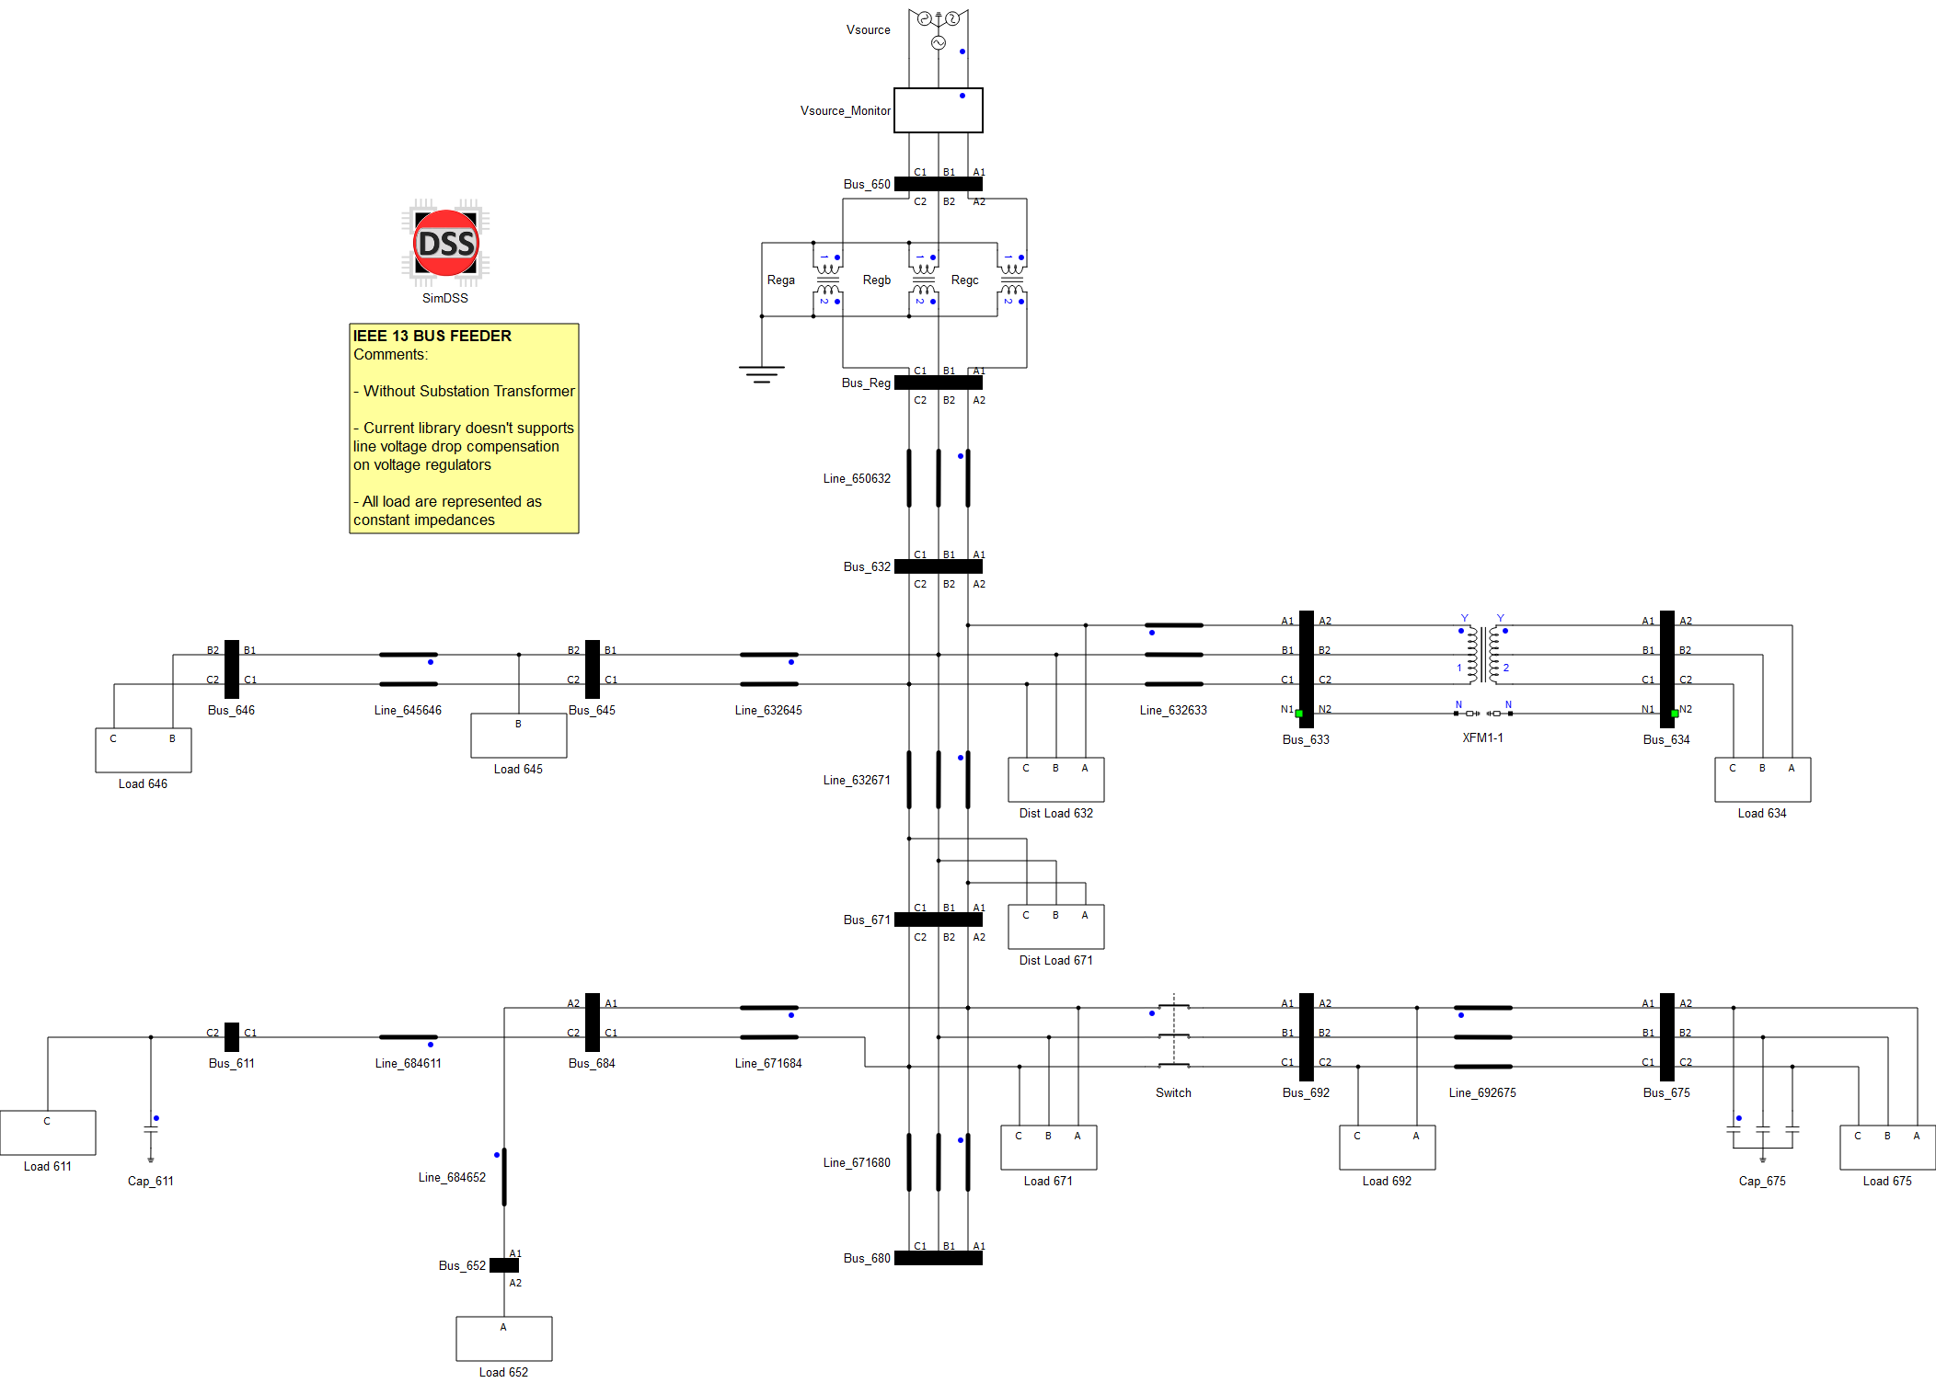
Figure 1 – Single Line diagram of the IEEE 13 Bus Feeder.
Figure 2 shows how to execute a snapshot simulation from the OpenDSS engine by clicking the “Run” button on the “Simulation” tab of the SimDSS component. The power flow results are accessed by the “Show” properties tab (Figure 2.b). After compiling and loading the model into the SCADA (VHIL+), the user can observe a similar operational point as shown in Table 1 – Table 3. The results show the IEEE reference against the OpenDSS and the HIL SCADA (runtime) implementations. Figure 3 shows the SCADA Panel running the IEEE 13 Bus simulation.

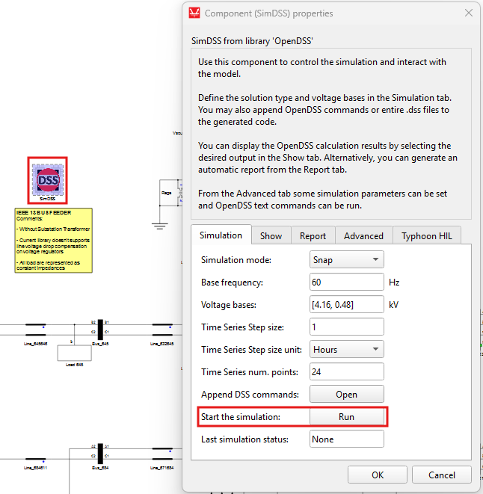 | 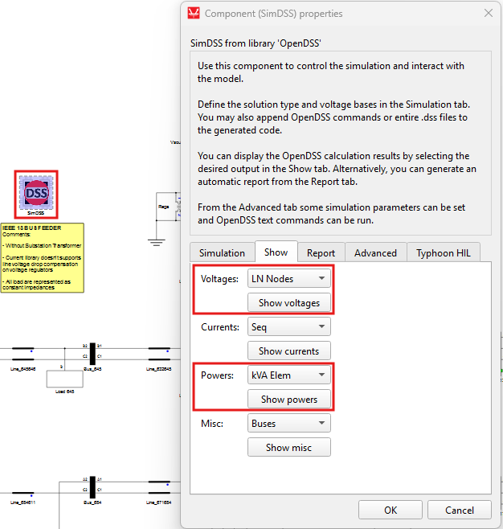
a) | b)
Figure 2 – a) running the OpenDSS simulation and b) getting the power flow results.

Results
Table 1. Power Flow – System Input.
# | IEEE  Phase A | DSS  Phase A | SCADA  Phase A | IEEE  Phase B | DSS  Phase B | SCADA  Phase B | IEEE  Phase C | DSS  Phase C | SCADA  Phase C
kW | 1251.398 | 1175.000 | 1148.630 | 977.332 | 1041.300 | 1017.119 | 1348.461 | 1288.100 | 1367.993
kvar | 681.570 | 654.200 | 653.87. | 373.418 | 409.700 | 398.557 | 669.784 | 772.600 | 751.164
kVA | 1424.968 | 1344.800 | 1321.704 | 1046.241 | 1119.000 | 1092.419 | 1505.642 | 1502.000 | 1560.658
PF | 0.8782 | 0.874 | 0.8691 | 0.9341 | 0.931 | 0.9311 | 0.8956 | 0.858 | 0.8765

Table 2. Power Flow – Load Voltages Magnitudes.
Bus/Node | Phase | IEEE | DSS | SCADA | Bus/Node | Phase | IEEE | DSS | SCADA
#650 | Va | 1.0000 | 0.9999 | 1.0017 | #671 | Va | 0.9900 | 0.9448 | 0.9348
#650 | Vb | 1.0000 | 1.0003 | 1.0003 | #671 | Vb | 1.0529 | 1.0583 | 1.0358
#650 | Vc | 1.0000 | 0.9998 | 0.9979 | #671 | Vc | 0.9778 | 0.9818 | 1.0146
#632 | Va | 1.0210 | 0.9925 | 0.9968 | #652 | Va | 0.9825 | 0.9377 | 0.9247
#632 | Vb | 1.0420 | 1.0483 | 1.0148 | #652 | Vb | -- | -- | --
#632 | Vc | 1.0174 | 1.0134 | 1.0392 | #652 | Vc | -- | -- | --
#634 | Va | 0.9940 | 0.9665 | 0.9433 | #611 | Va | -- | -- | --
#634 | Vb | 1.0218 | 1.0270 | 0.9906 | #611 | Vb | -- | -- | --
#634 | Vc | 0.9960 | 0.9923 | 1.0502 | #611 | Vc | 0.9738 | 0.9762 | 1.0133
#645 | Va | -- | -- | -- | #692 | Va | 0.9900 | 0.9447 | 0.9319
#645 | Vb | 1.0329 | 1.0387 | 1.0188 | #692 | Vb | 1.0529 | 1.0583 | --
#645 | Vc | 1.0155 | 1.0115 | -- | #692 | Vc | 0.9777 | 0.9818 | 1.0173
#646 | Va | -- | -- | -- | #675 | Va | 0.9835 | 0.9388 | 0.9269
#646 | Vb | 1.0311 | 1.0369 | 1.0171 | #675 | Vb | 1.0553 | 1.0604 | 1.0390
#646 | Vc | 1.0134 | 1.0094 | 1.0387 | #675 | Vc | 0.9758 | 0.9799 | 1.0132

Table 3. Power Flow – Load Voltages Errors.
Bus/Node | Phase | DSS | SCADA | Bus/Node | Phase | DSS | SCADA
#650 | Va | 0.01% | -0.17% | #671 | Va | 4.56% | 5.58%
#650 | Vb | -0.03% | -0.03% | #671 | Vb | -0.51% | 1.62%
#650 | Vc | 0.02% | 0.21% | #671 | Vc | -0.41% | -3.76%
#632 | Va | 2.80% | 2.37% | #652 | Va | 4.56% | 5.88%
#632 | Vb | -0.60% | 2.61% | #652 | Vb | -- | --
#632 | Vc | 0.39% | -2.14% | #652 | Vc | -- | --
#634 | Va | 2.77% | 5.10% | #611 | Va | -- | --
#634 | Vb | -0.51% | 3.05% | #611 | Vb | -- | --
#634 | Vc | 0.38% | -5.44% | #611 | Vc | -0.25% | -4.06%
#645 | Va | -- | -- | #692 | Va | 4.57% | 5.87%
#645 | Vb | -0.56% | 1.37% | #692 | Vb | -0.51% | --
#645 | Vc | 0.39% | -- | #692 | Vc | -0.41% | -4.05%
#646 | Va | -- | -- | #675 | Va | 4.55% | 5.75%
#646 | Vb | -0.56% | 1.36% | #675 | Vb | -0.48% | 1.54%
#646 | Vc | 0.39% | -2.50% | #675 | Vc | -0.42% | -3.83%

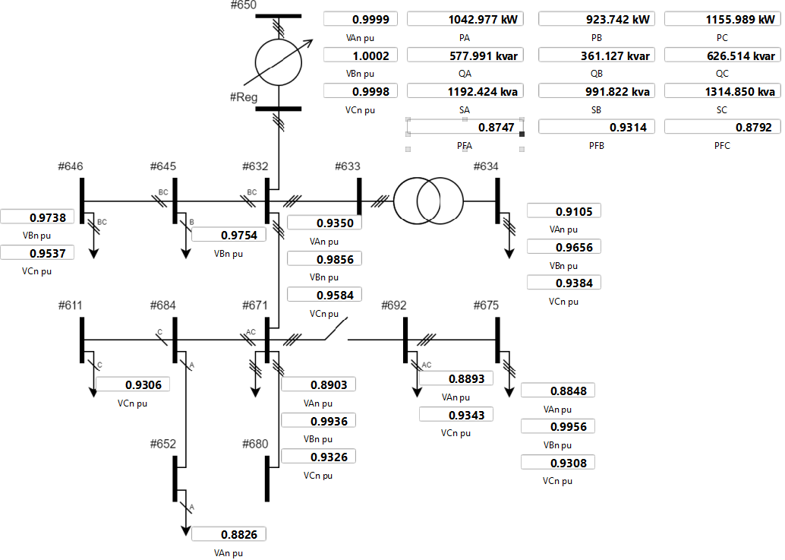
Figure 3 – SCADA Panel

Modeling Data
Table 4. Line Segment Data.
Line | From (#node) | To (#node) | Config ID | km | Phases
Line_650632 | #650 | #632 | 601 | 0.610 | ABC
Line_632645 | #632 | #645 | 603 | 0.152 | BC
Line_632633 | #632 | #633 | 602 | 0.152 | ABC
XFM-1 | #633 | #634 | 500 kVA – 4.16/0.48 kV (Ynyn); Z=1.1+2%
Line_645646 | #645 | #646 | 603 | 0.091 | BC
Line_632671 | #632 | #671 | 601 | 0.610 | ABC
Line_671684 | #671 | #684 | 604 | 0.091 | AC
Line_671680 | #671 | #680 | 601 | 0.305 | ABC
Switch | #671 | #692 | Static Switch (ABC)
Line_684652 | #684 | #652 | 607 | 0.244 | A
Line_684611 | #684 | #611 | 605 | 0.091 | C
Line_692675 | #692 | #675 | 606 | 0.152 | ABC

Table 5. Load Data.
Node | S_{A}  [kVA] | FP_{A} | S_{B}  [kVA] | FP_{B} | S_{C}  [kVA] | FP_{C} | Notes
#634 | 194.16 | 0.82 | 150.00 | 0.80 | 150.00 | 0.80 | Spot Load (Y ABC)
#645 | -- | -- | 211.01 | 0.81 | -- | -- | Spot Load (B)
#646 | -- | -- | 265.19 | 0.87 | -- | -- | Spot Load (BC)
#652 | 154.21 | 0.83 | -- | -- | -- | -- | Spot Load (A)
#671 | 443.42 | 0.87 | 443.42 | 0.87 | 443.42 | 0.87 | Spot Load (D ABC)
#675 | 520.89 | 0.93 | 90.69 | 0.75 | 359.23 | 0.81 | Spot Load (Y ABC)
#692 | -- | -- | -- | -- | 227.38 | 0.75 | Spot Load (AC)
#611 | -- | -- | -- | -- | 187.88 | 0.90 | Spot Load (C)
#632 | 19.72/2 | 0.86 | 76.16/2 | 0.87 | 135.33/2 | 0.86 | Distr. Load (Y ABC)
#671 | 19.72/2 | 0.86 | 76.16/2 | 0.87 | 135.33/2 | 0.86 | Distr. Load (Y ABC)
#675 | 200 | -- | 200 | -- | 200 | -- | Capacitor (Y ABC)
#611 | -- | -- | -- | -- | 100 | -- | Capacitor (C)

Table 6. Impedances for Configuration 601 (Linecode CONFIG_601).
Resistance Matrix (Ω/km) |  |  | Reactance Matrix (Ω/km) |  |  | Capacitance Matrix (nF/km)
0.2153 |  |  | 0.6325 |  |  | 10.3836
0.0969 | 0.2097 |  | 0.3117 | 0.6511 |  | -3.2896 | 9.8230
0.0982 | 0.0954 | 0.2121 | 0.0982 | 0.2392 | 0.6430 | -2.0760 | -1.2225 | 9.2938
Table 7. Impedances for Configuration 602 (Linecode CONFIG_602).
Resistance Matrix (Ω/km) |  |  | Reactance Matrix (Ω/km) |  |  | Capacitance Matrix (nF/km)
0.4676 |  |  | 0.7341 |  |  | 9.3933
0.0982 | 0.4645 |  | 0.2632 | 0.7446 |  | -1.7829 | 8.5371
0.0969 | 0.0954 | 0.4621 | 0.3117 | 0.2392 | 0.7526 | -2.7864 | -1.0859 | 8.9411
Table 8. Impedances for Configuration 603 (Linecode CONFIG_603).
Resistance Matrix (Ω/km) |  |  | Reactance Matrix (Ω/km) |  |  | Capacitance Matrix (nF/km)
-- |  |  | -- |  |  | --
-- | 0.8261 |  | -- | 0.8371 |  | -- | 7.7627
-- | 0.1284 | 0.8226 | -- | 0.2853 | 0.8431 | -- | -1.4833 | 7.6904
Table 9. Impedances for Configuration 604 (Linecode CONFIG_604).
Resistance Matrix (Ω/km) |  |  | Reactance Matrix (Ω/km) |  |  | Capacitance Matrix (nF/km)
0.8226 |  |  | 0.8431 |  |  | 7.6904
-- | -- |  | -- | -- |  | -- | --
0.1284 | -- | 0.8261 | 0.2853 | -- | 0.8371 | -1.4833 | -- | 7.7627

Table 10. Impedances for Configuration 605 (Linecode CONFIG_605).
Resistance Matrix (Ω/km) |  |  | Reactance Matrix (Ω/km) |  |  | Capacitance Matrix (nF/km)
-- |  |  | -- |  |  | --
-- | -- |  | -- | -- |  | -- | --
-- | -- | 0.8259 | -- | -- | 0.8373 | -- | -- | 7.4489

Table 11. Impedances for Configuration 606 (Linecode CONFIG_606).
Resistance Matrix (Ω/km) |  |  | Reactance Matrix (Ω/km) |  |  | Capacitance Matrix (nF/km)
0.4960 |  |  | 0.2773 |  |  | 159.6977
0.1983 | 0.4903 |  | 0.0204 | 0.2511 |  | -- | 159.6977
0.1770 | 0.1983 | 0.4960 | -0.0089 | 0.0204 | 0.2773 | -- | -- | 159.6977

Table 12. Impedances for Configuration 607 (Linecode CONFIG_607).
Resistance Matrix (Ω/km) |  |  | Reactance Matrix (Ω/km) |  |  | Capacitance Matrix (nF/km)
0.8342 |  |  | 0.3184 |  |  | 148.3273
-- | -- |  | -- | -- |  | -- | --
-- | -- | -- | -- | -- | -- | -- | -- | --

Table 13. Voltage Regulator Settings.
Regulator ID: | 1
Line Segment: | 650 - 632
Location: | 50
Phases: | A - B -C
Connection: | 3-Ph,LG
Monitoring Phase: | A-B-C
Bandwidth: | 2.0 volts
PT Ratio: | 20
Primary CT Rating:* | 700
Compensator Settings:* | Ph-A | Ph-B | Ph-C
R - Setting:* | 3 | 3 | 3
X - Setting:* | 9 | 9 | 9
Volltage Level: | 122 | 122 | 122

References
[1] – IEEE 13 Bus Feeder (https://cmte.ieee.org/pes-testfeeders/resources/)

